Exploring Angles in Circles
Suppose you want to see a concert in a circular amphitheater. You can purchase a ticket for any of the three seats denoted by the black dots on the picture to the right. Before you purchase your ticket, you think about which seat will have a better viewing angle of the stage. Which seat would you choose?
STAGE

Once you make your hypothesis, you can model the problem using Geogebra to see if you made the best choice of seats for the concert.

- Open Geogebra on your computer. Right click on the screen and click GRID and AXES to turn both off. Then, click the OPTION tab at the top of the screen, click LABELING, then click NO NEW OBJECTS.

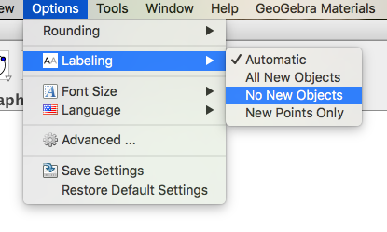
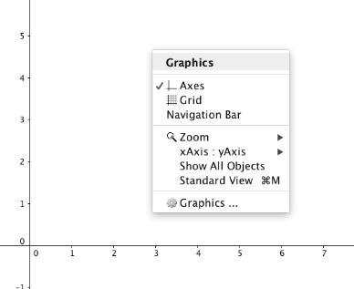

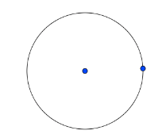
- Click the 6th square icon on the top and select CIRCLE WITH CENTER THROUGH POINT. Click on the screen and drag the mouse to create a circle of any size to represent the amphitheater.

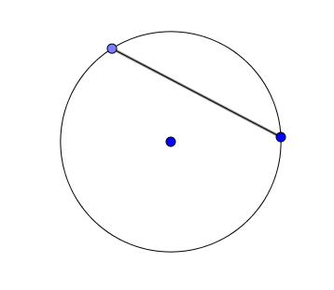
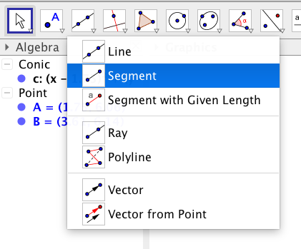
- Click on the 3rd square icon on the top and select SEGMENT. Draw a segment from the blue point on the circle to another spot on the circle. Both ends of the segment MUST fall on the circle. This segment marks the edge of the stage. Click the 10th square icon on the top and select TEXT. Click inside the “stage” area, type the word STAGE, and then click OK.

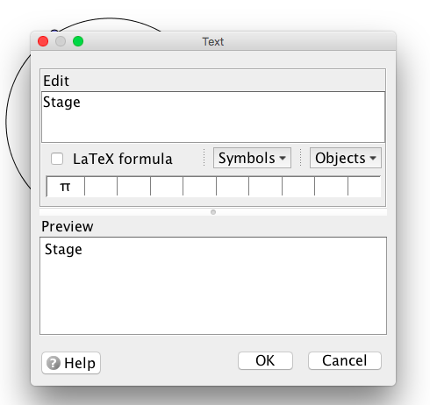
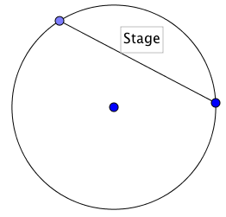

- Click the 2nd square icon on the top, select POINT, and plot three points on the circle to represent the seats available.

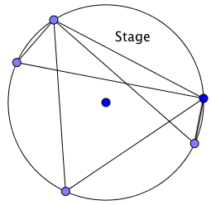
- Click the 3rd square icon on the top and select SEGMENT. Click to draw a segment from each end point of the stage to each of the “seat” points. You can now see the viewing angle of the stage from each seat.
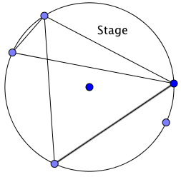
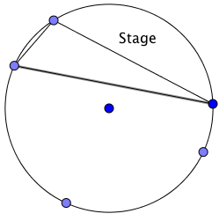

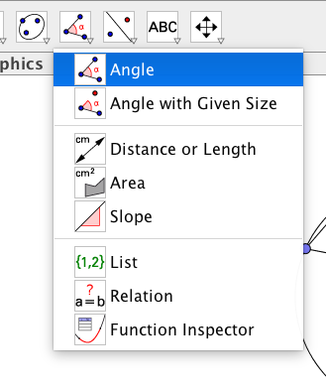
- Click the 8th square icon on the top and select ANGLE. To find the measure of each angle, click on each point from right-most point, to the middle point, to the left-most point. Repeat with all three angles. What do you notice? Did you make the best choice when you chose your seat?

- Check to see if the angles remain equal to one another if you make the amphitheater larger, change the size of the stage, or move the location of the seats. You can do this by clicking the 1st square icon on the top, clicking one of the points on the circle, and dragging the point around.
What did we discover?
Inscribed Angles: an angle formed by two chords in a circle which have a common
endpoint. The common endpoint forms the vertex of the angle. The
other two endpoints define what we call an intercepted arc on the circle.
Conjecture: In a circle, two inscribed angles with the same intercepted arc are
congruent.

