Möbius Strips
Goal: -The students will learn about the characteristics of a Möbius Strip. -The students will discover relationships between the number of twists in the strip and the number of edges and sides present.
Objective: -Given a strip of paper and tape, the student will create a Möbius Strip. -Using the Möbius Strip they created, the student will determine the number of edges and sides of the Möbius Strip. -Using information from some trials on the data chart, the students will predict a relationship between the number of twists in the strip and the number of edges and sides that it has. -Using strips of paper, tape, and a chart, the student will state the relationship between the number of twists in the strip and the number of edges and sides that it has.
Materials: -Multiple strips of paper -Tape -Data Chart
Creating a Möbius Strip
To create the Möbius strip, take a strip of paper and pull the two ends together. Before taping them together, take one end and twist it 180˚. Then, secure the ends together with tape. You now have created a Möbius Strip.
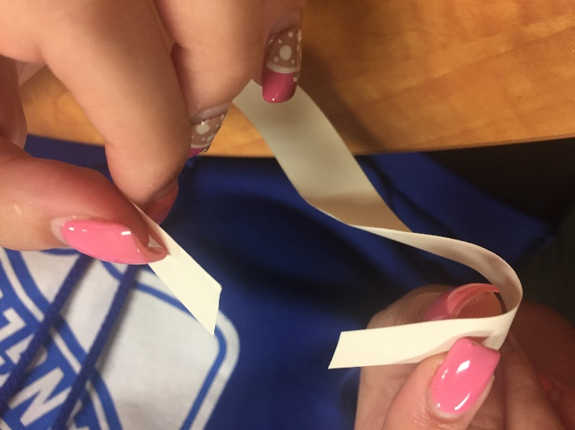
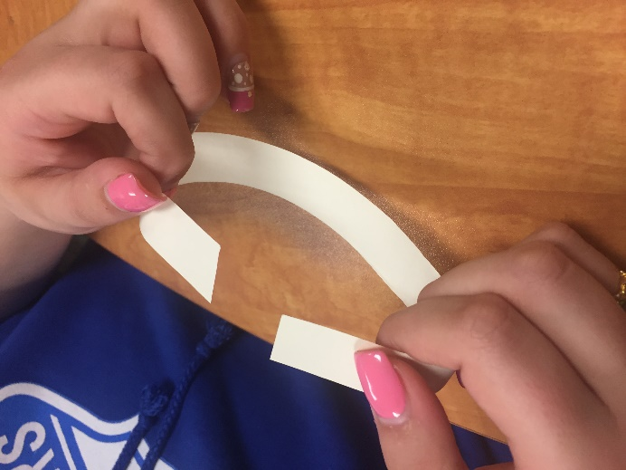

The Möbius Strip is named after August Ferdinand Möbius, a nineteenth century German mathematician and astronomer who was a pioneer in the field of topology. The design of the Möbius Strip has practical applications in industry. The design has been used for conveyor belts and continuous-loop recording tapes. You’ll find out why these design work best after you complete this activity!

What Makes This a Möbius Strip?
Take a pencil and place it in the center of the strip. Draw a straight line around the strip until you reach where you started without lifting the pencil. What do you notice? What do you think this shows about the Möbius Strip?

*Characteristic #1 of a Möbius Strip: _______________________________________________*

Now take a highlighter/marker a place it on an edge of the strip. Color along the edge until you reach where you started without lifting the highlighter/marker. What do you notice? What do you think this shows about the Möbius Strip?

*Characteristic #2 of a Möbius Strip: _______________________________________________*

Can We Find Patterns?
Using the information we just found fill in the data chart for the number of sides and edges for a Möbius Strip (1- 180$°$ twist). Using the other strips, complete the same process as above with each number of 180$°$ twists. Determine the number of sides and edges for each and fill out the data chart.
Do you see any patterns? What are they?

